**WEB ICP 1**

**GITHUB INSTALATION**

Create an account in github: <https://github.com/>

Create a new repository

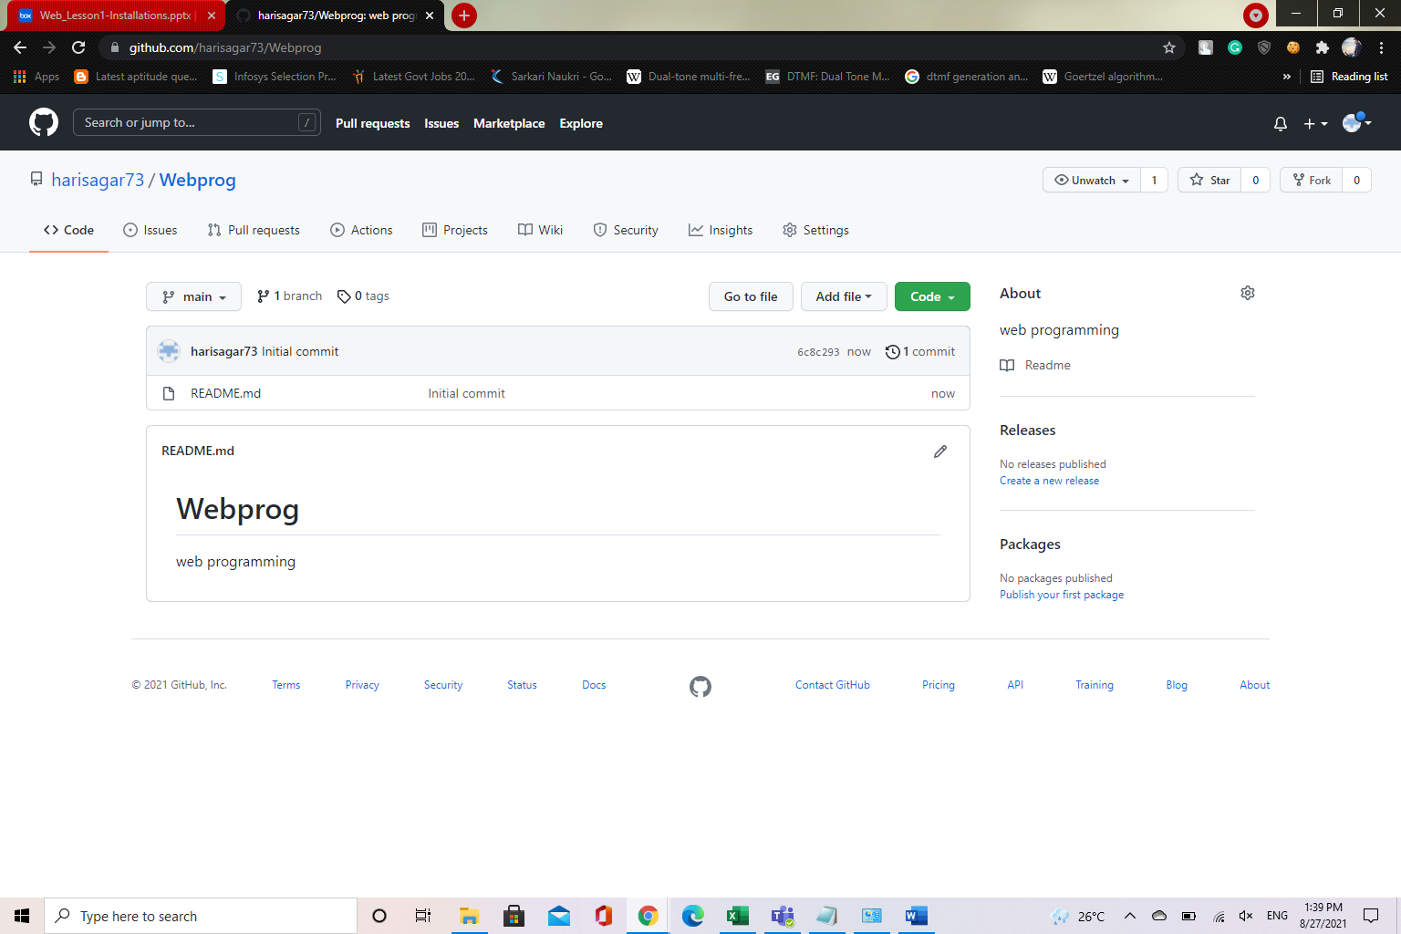

Download and install GITHUB: <https://desktop.github.com/>

Create a file and add to project

File added in github and commit file

Push the file to cloud and checking cloud

**WEBSTORM IDE INSTALLATION**

**Create a account using umkc email id:** [**https://www.jetbrains.com/**](https://www.jetbrains.com/)

**Install webstorm ide desktop:** [**https://www.jetbrains.com/webstorm/**](https://www.jetbrains.com/webstorm/)



